**TASK 1 A**

**Objective:** Write a program that takes character input until user press ‘k’. Use do while.

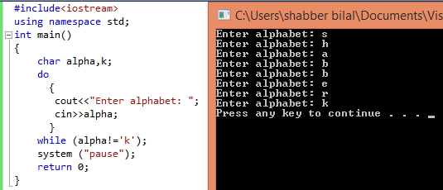

**TASK 1 B**

**Objective:** Write a program that takes three numbers as input. Print their sum, largest number and smallest number. Ask user “do you want continue press y and n for quit”. Use do while loop.

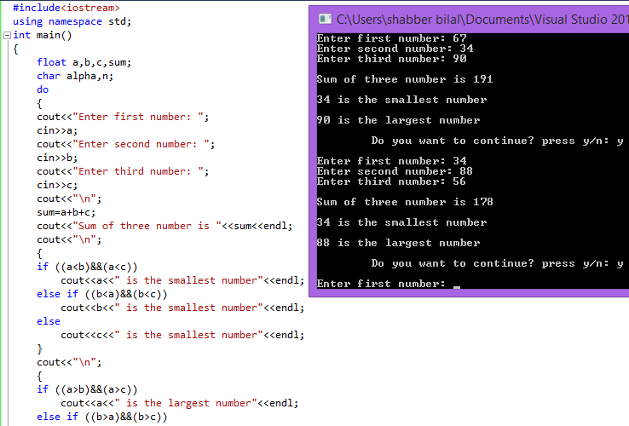

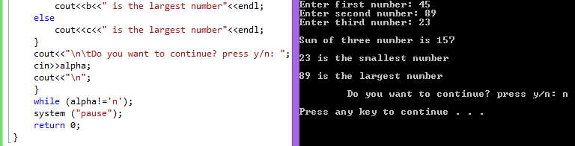

**TASK 2**

**Objective:** Write a program that displays following pattern.

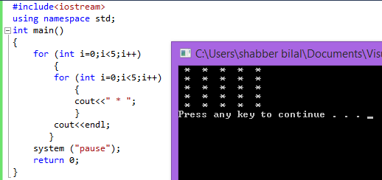

**TASK 3**

**Objective:** Write a program that displays following output.

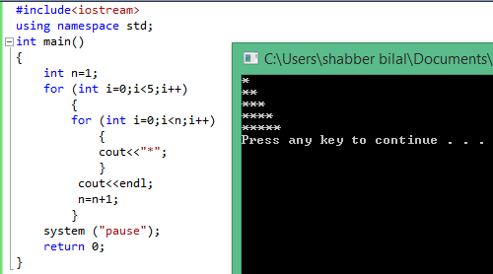

**TASK 4**

**Objective:** Write a program that displays following output.

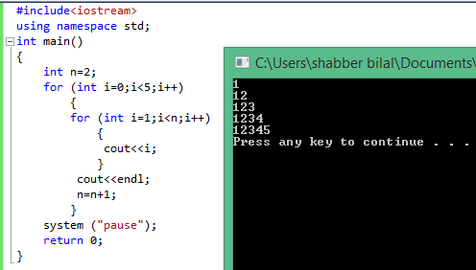

**TASK 5**

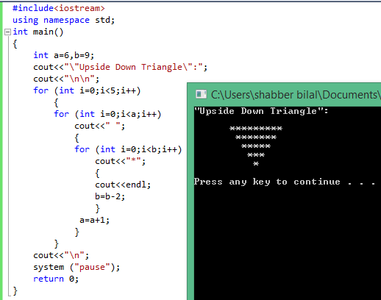**Objective:** Write a program that displays following output.